DIS-Eur-Vinca-Female- with skirt

Ex: Michael Davies 2 hanover court Didcot Oxfordshire ox11 8nu United Kingdom

Item length: 13.5 cm

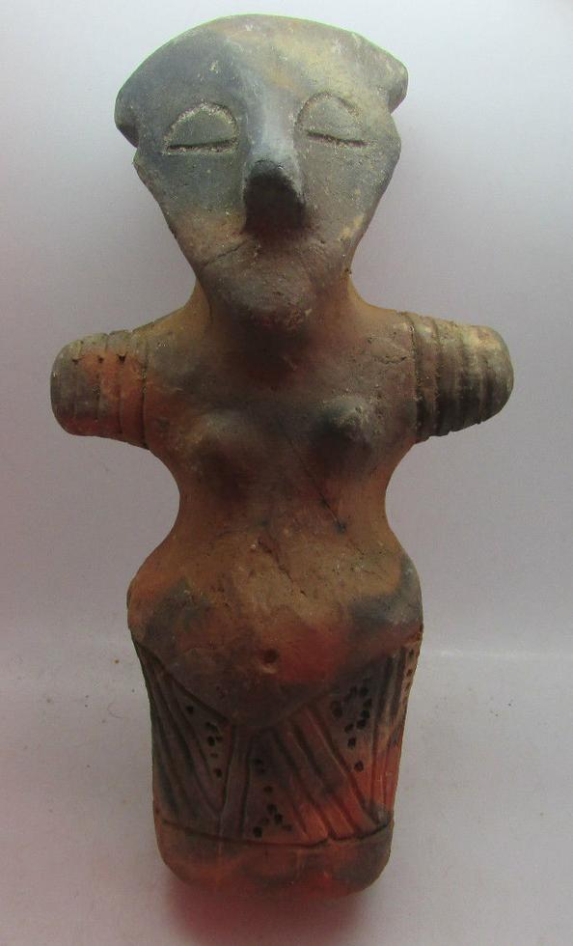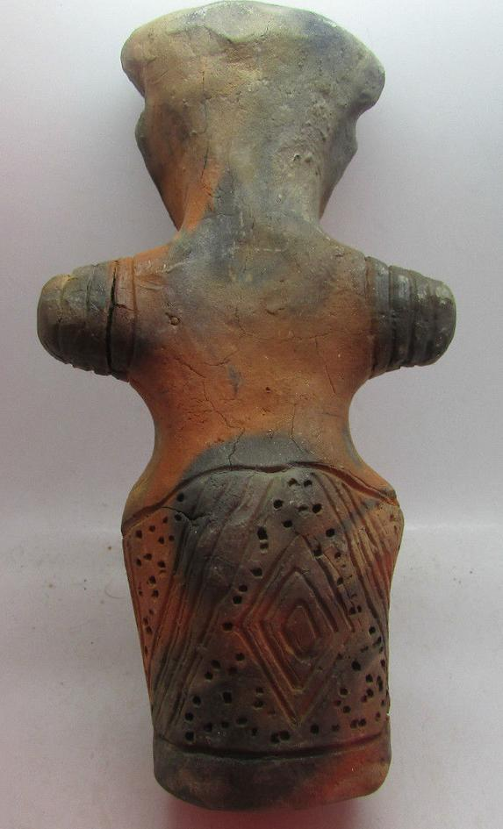

# Order details

## Sales order

Sold by [mikes-artefacts](http://myworld.ebay.com/mikes-artefacts) ( [874](http://feedback.ebay.com/ws/eBayISAPI.dll?ViewFeedback&userid=mikes-artefacts) )

### Delivery package 1 of 1

No estimate available

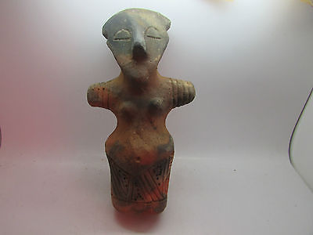

#### [Rare ancient Prehistoric anthromorphic Vinca figurine C. 4500BC](http://www.ebay.com/itm/152039692747)

|  |  |
| --- | --- |
| Item price | GBP 250.00 |
| Quantity | 1 |
| Item number | 152039692747 |
| Shipping service | Royal Mail International Tracked |

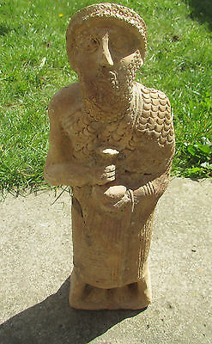

#### [Extremely rare huge West Asian terracotta worshipper C. 2800-2000BCE](http://www.ebay.com/itm/152065061010)

|  |  |
| --- | --- |
| Item price | GBP 1,000.00 |
| Quantity | 1 |
| Item number | 152065061010 |
| Shipping service | Royal Mail International Tracked |

## Shipping address

Ralph J Coffman Jr

149 Atlantic Ave

Swampscott MA 01907-2427

United States

## Order total

|  |  |
| --- | --- |
| Subtotal | GBP 1,250.00 |
| Shipping | GBP 38.00 |

**Total**

GBP 1,288.00

Order placed on

Saturday, Apr 23, 2016

Payment method

Credit card

Payment date

Saturday, Apr 23, 2016